“Yes, you can be an architect AND a woman!”
Women in Architecture: Queensland 1982-1989

From the 1970s social and political changes in Australia and the burgeoning feminist movement were challenging established power relationships and hierarchies. This paper explores how in the 1980s groups of women architects actively took positions that were outside the established professional mainstream. A 1982 seminar at the University of Queensland galvanised women in Brisbane to form the Association of Women Architects, Town Planners and Landscape Architects. Formally founded the association was multi-disciplinary and not affiliated with the established bodies. Its aims included promoting women and working to reform the practice of these professions. While predominately made up of architects, the group never became part of the Royal Australian Institutes of Architects, it did inject itself into its activities, spectacularly sponsoring the Indian architect Revathi Kamath to speak at the 1984 RAIA. For five years the group was active organising talks, speakers, a newsletter and participating in Architecture Week. In 1984 an exhibition ‘Profile: Women in Architecture’ featured the work of 40 past and present women architects and students, including a profile of Queensland’s then oldest practitioner Beatrice Hutton. Sydney architect Eve Laron, the convenor of Constructive Women in Sydney opened the exhibition. There was an active interchange between Women in Architecture in Melbourne, Constructive Women, and the Queensland group, with architects such as Ann Keddie, Suzanne Dance and Barbara van den Broek speaking in Brisbane. While the focus of the group centred around women’s issues such as traditional prejudice, conflicting commitments and retraining, its architectural interests were not those of conventional practice. It explored and promoted the design of cities and buildings that were sensitive to users including women and children, design using natural materials and sustainability. While the group only existed for a short period, it advanced positions and perspectives that were
outside the mainstream of architectural discourse and practice. Nearly 40 years on a new generation of women is leading the debate into the structural inequities in the architectural profession which are very similar to those tackled by women architects in the 1980s.

Keywords: Women in Architecture, Constructive Women, Association Women in Architecture, pioneering women architects, RAIA Convention ‘Functions of Architecture’, Revathi Kamath.

Background
In Australia from the 1970s, social and political changes and the burgeoning feminist movement were challenging established power relationships and hierarchies. This paper examines the interests and activities of the Women in Architecture Association established in Brisbane in 1983. This was part of a more general movement in Australia of professional women forming associations. It paralleled groups in other states also operating outside the architectural mainstream, such as Melbourne’s Association Women in Architecture founded in in 1979, and Sydney’s Constructive Women established in 1983. The number of women enrolling in architectural courses in Queensland had started to grow from the early 1960s and was significantly increased by the Whitlam Government’s abolition of university fees in January 1974. As shown by the 1986 Royal Australian Institute of Architects’ (RAIA) report ‘Women in the Architectural Profession’, in 1985 the percentages of female first year students at the University of Queensland and the Queensland Institute of Technology were 38.7% and 25% respectively, whereas by 1987 women accounted for half the University of Queensland’s first year enrolments.

The Women in Architecture Association was formed on the wave of this influx of women entering the profession in Queensland. The Association’s objective was to promote women architects in the community and combat discrimination against women in architectural practice. Its interests extended beyond conventional architectural practice to include the experience of previous women practitioners and the design of cities and buildings to be more responsive to the needs of women and children. While the group existed for only a short time, it advanced positions and perspectives that were outside the mainstream of architectural discourse and practice. Nearly 40 years on, a new generation of women are leading the debate into the structural inequities in the architectural profession which are very similar to those tackled by women architects in the 1980s.

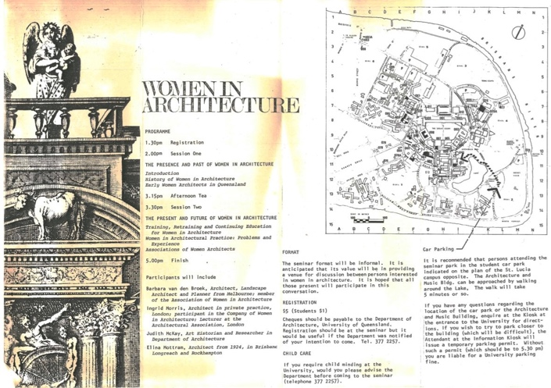
Figure 1. Program for Women in Architecture seminar, 1 September 1982.
Source: Women in Architecture Records, UQFL649.

1982 – Stimulus
The first seminar in Queensland on the role of women in architecture was held at the University of Queensland on 1 September 1982. This was organised by Donald Watson, a lecturer in the Department of Architecture, and leveraged off the presence of visiting lecturer Ingrid Morris, a London-based architect, sole practitioner, and teacher at the Architectural Association School of Architecture. The publicity for the seminar stated that it would canvass issues such as: training, retraining and continuing education for women in architecture; problems of women architects in practice and experiments to overcome them; forms of association and programs emerging from such groups to help overcome problems for women architects; and the history of women architects in Australia and overseas. With advertisements in The Courier-Mail newspaper and the RAIA’s Chapter News the seminar attracted 72 people, predominately women, including architects, graduates, students and a Toowoomba schoolgirl who planned to study architecture. Those who attended remember it as a very exciting and inspiring day. Amongst the participants were a number of early women architects: Elina Mottram (1903-1996), Olive Withy, née Cannan (1904-2000), Georgette Cusack, née Boxall, and Ann Harrison, née Greenfield (1933- 2013).

The program for the seminar was arranged around the topics ‘The Presence and Past of Women in Architecture’ and the ‘Present and Future of Women in Architecture’. Donald Watson set the scene with a general history on women in architecture from an international and Australian perspective. He discussed early women architects in the United States of America and Australian pioneers such as Marion Mahony Griffin (1871-1961) and Florence Taylor (1879-1969). Judith McKay, a research assistant in the Department of Architecture, who with Donald Watson was researching architects practising in Queensland to 1940, spoke next. It was as part of this project that Judith had uncovered a number of early Queensland woman architects. She presented her research on these pioneering women architects, including Beatrice Hutton (1893-1990), the first woman admitted to an architectural institute in Australia when she became a member of the Queensland Institute of Architects in 1916. Judith also highlighted Lily Addison who had studied architectural subjects at the Brisbane Technical College in 1914 and worked in the office of her father, architect GHM Addison. The careers of public servants Dorothy Brennan and Ursula Jones, draughtswomen and architects, in the Queensland Works Department and Housing Commission were also documented. Judith McKay’s research presented at the seminar is recognised as foundational by Julie Willis and Bronwyn Hanna in ‘Women Architects in Australia 1900-1950’. It has led to Beatrice Hutton being included in the Australian Dictionary of Biography and two buildings designed by Elina Mottram—Monkton (1925) and the Scott Street Flats, Kangaroo Point (1925)— being entered in the Queensland Heritage Register. Also a successful court case to prevent the demolition of a residential building Uanda (1928) designed by Nellie McCredie (1901-1968) and a doctoral theses on the work of McCredie.

Ingrid Morris spoke of her own experience being a member of a London collective, the Company of Women in Architecture, founded in 1974 by architect Santa Raymond. The difficulties of obtaining commissions during an economic downturn meant that the collective struggled and did not survive. Ingrid believed that while woman architects were as capable as men, the work that they were able to get when they graduated tended to be small jobs, renovations, kitchens and bathrooms. “There is a great reluctance on the part of the wealthy, cigar-smoking land developer to entrust his million dollar project to a female architect,” she said. The recently retired Elina Mottram, the star of Queensland women’, and the state’s first woman architect to establish her own practice (in 1924), also spoke. She talked about her varied professional experiences including establishing sole practice and working for Queensland Railways. Barbara van den Broek (1932-2001), an architect, landscape architect and planner who had practised in Brisbane for 20 years was the final speaker and provided insights into her career. Barbara had just relocated to Melbourne and joined its Association of Women in Architecture.

1983 – Establishing Women in Architecture
The 1982 seminar galvanised women architects in Brisbane, and a small group worked on defining the objectives and drafting a constitution for an association. The first meeting was held during Architecture Week, on 22 June 1983, with 17 women in attendance. There was a lively debate about the structure of the group, whether it should affiliate with the RAIA and the types of memberships and fees. The need for the group was whole-heatedly supported and a range of objectives were discussed, including the promotion of women architects in the community; combatting discrimination against women in architectural practice; providing support for women temporarily out of the workforce; job sharing; developing the confidence and self-belief of women architects; continuing education; and networking with other professional women to foster friendship and mutual support.

From its inception the Association was multi-disciplinary, largely made up of architects with a small number of planners and landscape architects also active members. The Association did not affiliate with any established professional bodies and this remained a subject of continued debate within the membership over its five years of activity. Similar debates occurred within Constructive Women and the Association Women in Architecture, with both groups deciding not to become sub-groups of the professional institutes. However, the importance of the institutes was acknowledged with women’s groups realising that they needed to be active within them. In 1984 Dimity Reed, a founder of the Association Women in Architecture, was elected as the first female president of the Victorian Chapter of the RAIA. In Queensland, the relationship between the Association and the RAIA was cooperative, with the Association generally holding its meetings at the RAIA premises in Albert Street, Brisbane and receiving funding to participate in RAIA activities such as Architecture Week. In 1982 Patrice Derrington, one of the Association’s founding members, became the first woman elected to the council of the RAIA Queensland Chapter. Her presence on the RAIA council meant there was a direct line of communication between the two groups. The Association encouraged the RAIA to act against discrimination in employment; for example, the advertising of jobs in the ‘Men and Boys’ section of newspapers. The need to encourage women to nominate for the RAIA council was an ongoing consideration for the Association and it also lobbied the Board of Architects of Queensland to have women on the panel for architectural registration examinations.

As part of the Association’s objective to provide continuing education, its monthly meetings of often featured guest speakers or were coordinated to take advantage of visiting women speakers at the Brisbane Community Arts Centre talks. The local architectural scene was energised during the period 1981 to 1985 by a series of fortnightly talks ‘Architecture is a Community Art’ organised by Donald Watson and the University of Queensland. The purpose of these public talks was to foster debate and interest in architecture. They included a remarkable range of local, Australian and international speakers, both prominent and early career architects, critics and commentators. For the Association, this lecture series provided the opportunity to interact with and bring a number of women architects to Brisbane, including Suzanne Dance, Elizabeth Farrelly, Ann Keddie, Alison Smithson and Dimity Reed. The Association was also interested in how other women’s professional groups had formed and operated. It saw liaison with other women professionals as not only informative but also a means of raising the profile of women architects with potential clients. At the October 1983 meeting Leneen Forde, the founding President of the Queensland Women Lawyers Association and later Queensland Governor, spoke about the early years of this group, how it was organised and its activities to promote law reform relating to women and children. In following years other speakers provided practical advice for practising architects, including an accountant from Price Waterhouse on tax, a banker on financing development projects and risk assessment, the art of negotiating and marketing tips for women architects.

1984 Exhibition - ‘Profile: Women in Architecture’
The year 1984 was a highpoint for the Association with the membership energetic and ambitious to promote the work of women architects. The Association participated in Architecture Week by staging an exhibition ‘Profile: Women in Architecture’ which aimed to ‘…show the number of women involved in architecture and the diversity of their interests, past, present and future’. The exhibition was convened by Brit Andresen and Helen Josephson. Brit was the first female architecture lecturer employed by the University of Queensland, taking up her appointment in 1977. The exhibition featured the work of 40 past and present women architects, graduates and students. Held at the John Mills Himself Building in Charlotte Street, Brisbane, it opened on 12 June 1984 and ran for four days. In the lead-up, a weekend workshop was held at the University of Queensland Architecture School to enable the exhibitors to prepare their material in a collaborative environment. Each participant was asked to provide A4 and A1 boards with black and white text and illustrations, including drawings, photographs and curriculum vitae. Research was undertaken and exhibition boards prepared with the names of all the woman graduates from the two local architecture schools, the University of Queensland and the Queensland University of Technology. Although nearly 90 years old, Queensland’s then oldest woman practitioner, Beatrice Hutton, agreed to be interviewed by Association members and a profile of her career was prepared for the exhibition. To publicise the event Association members were interviewed on radio programs. The Sydney architect Eve Laron, the convenor of Constructive Women, opened the exhibition which was covered by the local press—in the social and women’s pages.

1984 Convention - ‘Functions of Architecture’
The week after the exhibition the Association spectacularly injected itself into the 1984 RAIA National Convention in Brisbane, ‘Functions of Architecture’, by sponsoring the Indian architect Revathi Kamath as a speaker. Although some funding was available from the Institute’s convention organising committee, the Association, led by Fiona Gardiner, had obtained sponsorship from Air India and AEQB drafting supplies. The Association also lobbied successfully for day/session tickets for attendees at the convention as the cost was a barrier to many women. Revathi Kamath, then 29 years old, practised in New Delhi with her husband Vasant Kamath. She spoke about her work as architect of the Shardipur Development community housing project for the street artists and craftspeople squatting outside New Delhi. Kamath illustrated her methods for studying how the squatters lived, looking at their problems, how they spatially related their sleeping, cooking and storing arrangements, and how they divided space for different functions. Using traditional Indian building materials and techniques, Kamath incorporated her observations into her designs. As a social action architect Revathi Kamath embodied many of the issues that interested the Association. Initially considered a bit of a sideshow, she made a considerable impact on the conference, with Haigh Beck inviting her to be part of its concluding session along with Ralph Erskine and Henri Ciriani. ‘Summing up the overall effect the conference’ would ‘have on future architecture in Australia, the president of the NSW chapter of the RAIA, Mr Chris Johnson, said that the surprise of the conference was the Indian architect, Revathi Kamath, who presented an “incredibly sensitive approach to architecture”’.

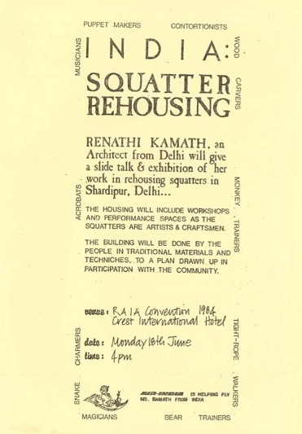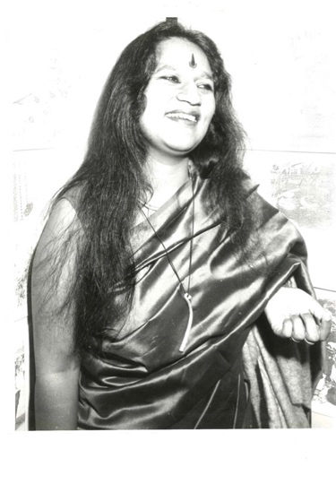
Figure 2 (left). Flyer for talk by Revathi Kamath.
Source: Women in Architecture Records, UQFL649.
Figure 3 (right). Photo of Revathi Kamath at RAIA Convention.
Source: Women in Architecture Records, UQFL649.

Activities 1985-1988
Following the successes of 1984, the Association continued to promote women architects through a range of activities relating to urban design, heritage and design for women and children. In 1985 the Association supported the newly elected Lord Mayor of Brisbane Sallyanne Atkinson in her attempt to stop the demolition of the New York Hotel in Queen Street in the city. A lunch was then held with the Lord Mayor to exchange ideas. Submissions were also prepared on a proposed Botanic Gardens development and on a review of the Brisbane Town Plan, with comments on parking requirements at shopping centres and appropriate zoning for childcare centres. Design for children was an ongoing interest of the Association, and in 1986 it launched a brochure ‘Playgrounds Child’s Play?’ prepared by Catherine Baudet, Helen Davis, and Jan Seto. Committed to improving the design standards and promoting better and safer playgrounds, the brochure covered such aspects as equipment, climatic considerations, and landscape, and included information about Australian Standards and avenues for funding. It received considerable media coverage and was widely distributed.

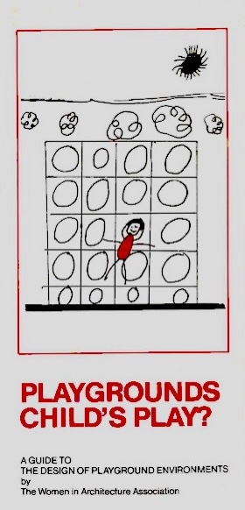
Figure 4. Brochure: Playgrounds Child’s Play?
Source: Women in Architecture Records, UQFL649.

Exchange between Victoria and NSW
There was an active interchange between Melbourne’s Association Women in Architecture, Sydney’s Constructive Women and the Queensland group. The exchanges included sharing information, newsletters and an invitation to the Melbourne group’s Women’s Winter School in Architecture and Feminism. This workshop was held over the 1984 June long weekend at Healesville, near Melbourne. Most of the participants were local but a few came from Adelaide, Sydney and Nimbin. The invitation to Revathi Kamath to speak at the previously-mentioned ‘Functions of Architecture’ convention came about because University of Queensland graduate Helen Wilson was lecturing at the University of Sydney and an active member of Constructive Women. Helen facilitated the invitation as she had visited the Shardipur community housing project and met Revathi while on a trip to India. During the 1984 convention the Association hosted a women’s dinner and 11 woman delegates from around Australia attended. The Melbourne architect Anne Keddie reported enthusiastically to her Victorian colleagues on the convention, Revathi Kamath’s workshop and meeting the members of the Queensland Association. In 1985 the Association joined with the other two groups to sponsor an Australian lecture tour by the internationally renowned architect and educator Dr Aase Eriksen. Aase was the designer of the America Architect-in-Schools program, a participatory design process in which children were involved in the design and construction of their environments.

‘Life got in the way’
For five years the Association was very active organising talks, speakers, a newsletter, brochures, board room lunches, social activities and participation in Architecture Week. However, by 1987 concerns were being expressed about declining membership and the possibility of less formal and less regular meetings. There was a feeling among more recent graduates that the Association was not relevant to them. Justine Clarke has identified this as one of the myths of Architecture…younger women see it all as a thing of the past – they have done well so far and see no reason why that won’t continue. The battles have already been fought, and they will reap the rewards. The Association seemed to run out steam by 1989-90; as Catherine Baudet said, …life got in the way. It stopped meeting formally and the bank account was eventually closed with the remaining funds donated to a woman’s shelter.

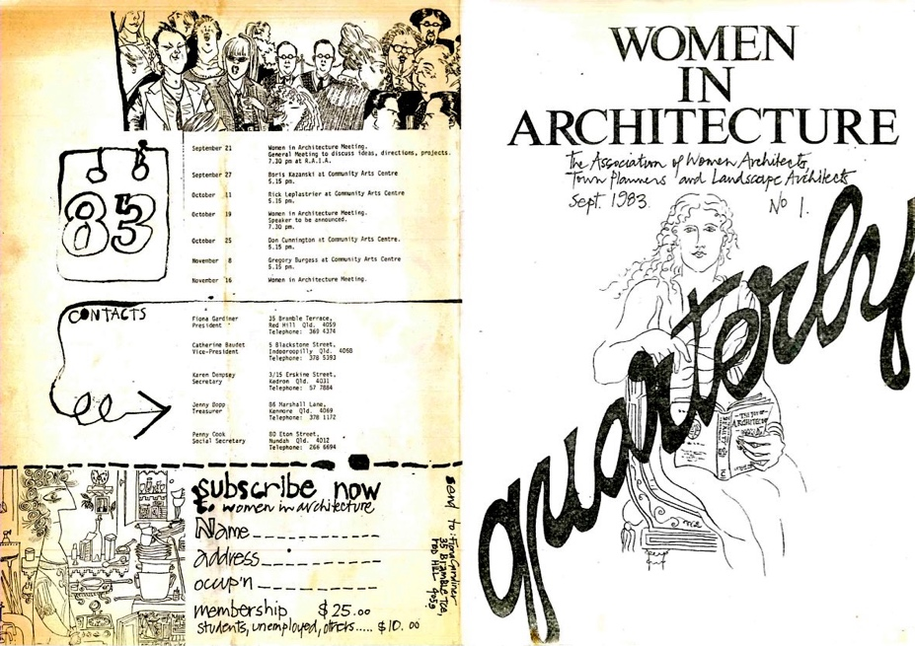
Figure 5. Women in Architecture: Newsletter September 1983.
Source: Women in Architecture Records, UQFL649.

Fifteen years later, in 2005, Paula Whitman, a lecturer in architecture at Queensland University of Technology, produced a report titled ‘Going Places: The Career Progression of Women in the Architectural Profession’. It painted a bleak picture, stating that despite …an increasing proportion of female students studying architecture over recent decades, there continues to be a lack of women in senior roles within architectural practice. In 2004, 2175 architects were registered in Queensland but only 253, 11.6% were women. Many of the issues identified by the Association and its activities to overcome barriers in architectural practice foreshadow Paula’s 12 findings and 10 recommendations. These were, in particular, the need for equal opportunity policies and flexible working arrangements, support for women to re-enter the profession, recognition of non-linear and interrupted career paths, equal opportunity registration procedures, membership of the RAIA and mentoring of women in practice. The research project ‘Equity and Diversity in the Australian Architecture Profession: Women, Work and Leadership’(2011-2014), built on Paula Whitman’s report, interrogating the patterns of women’s participation, progression and representation in the architectural profession, paying particular attention to women’s under-representation in senior management. The quantitative and qualitative research undertaken for this project highlights the gender inequities that are part of the structure of the contemporary architecture profession and remain very similar to those tackled by women architects in the 1980s.

Postscript
Although ‘life got in the way’ for the 1980s Women in Architecture Association in Queensland, many of its members went on to have long and notable careers. The convenor of the 1984 exhibition, Professor Brit Andresen, is a distinguished academic and design architect, her achievements being recognised in 2002 when she became the first woman to be awarded the RAIA’s Gold Medal. Professor Susan Savage and Dr Jean Sim had successful careers as academics at Queensland University of Technology, and Susan Savage was Chairperson of the Board of Architects of Queensland for 15 years. Professor Patrice Derrington is an academic and highly respected real estate expert based in New York. Catherine Baudet, Penny Campbell, Elizabeth Watson-Brown and Ruth Woods have all been principals in their own architectural practices. Elizabeth later merged her practice with a large national firm where she became a design director. Catherine Baudet was awarded the inaugural Paula Whitman Leadership in Gender Equity Prize in 2017. Fiona Gardiner and Ruth Woods specialised in heritage conservation and Fiona Gardiner was awarded the Public Service Medal for her contribution to the conservation and protection of Queensland’s heritage.

Shrimpton, Nikki, “Yes, you can be an architect AND a woman!”, Telegraph, 7 June 1984.
Women Lawyers Association of Queensland formed 1978, (website), accessed 16 July 2021, https://wlaq.com.au/.
Harriet Edquist, “Architecture and Design”, in The Encyclopedia of Women and Leadership in Twentieth Entry Australia, (Australian Women’s Archives Project, 2014), accessed 15 July 2021. http://www.womenaustralia.info/leaders/biogs/WLE0030b.htm
Harriet Edquist, “Architecture and Design”.
Russell Darroch and John Dean, Women in the Architectural Profession: Report to the Human Rights Commission (Royal Australian Institute of Architects, 1986), 18, accessed 19 July 2021https://archiparlour.org/wp-content/uploads/2012/04/Women-in-the-architectural-profession-1986_sml.pdf.
Ian Sinnamon and Michael Keniger, Ideas into Practice, (Department of Architecture: University of Queensland, 1987), 16.
Donald Watson LFSAHANZ LFRAIA was awarded the 2021 Gold Medal, Architecture Australia, (May/June 2021).
Press release for the women in Architecture seminar, n.d., Women in Architecture Records, UQFL649, Fryer Library, The University of Queensland Library.
“Woman as architects”, Courier Mail, n.d. and Chapter News (Jun-July 1982), Women in Architecture Records, UQFL649.
Louise Noble, “Selected works 1974-2010”, Architecture Australia, (May/June 2021), 89.
Verbal communication with Judith McKay, 13 June 2021 and Catherine Baudet, 12 July 2021.
Digital Archive of Queensland Architecture, “Olive Cannan”, (Web Page), accessed 21 July 2021, https://qldarch.net/architect/summary?architectId=775.
Georgette Boxall is first registered as an architect (number 361) on 16 February 1953 with her address as the Department of Works. Queensland Government Gazette (No. 61, 7 March 1953), 863.
Digital Archive of Queensland Architecture, “Ann Elisabeth Greenfield”, (Web Page), accessed 21 July 2021, https://qldarch.net/architect/summary?architectId=550.
Verbal communication with Donald Watson, 10 July 2021.
Anne Watson, “Marion Mahony Griffin: Architect, Environmentalist, Visionary”, Sydney Living Museums (Web Page), accessed 22 July 2021, https://sydneylivingmuseums.com.au/stories/.
Christa Ludlow, “Taylor Florence Mary (1879-1969)”, Australian Dictionary of Biography, (National Centre of Biograph, Australian National University, 1990) https://adb.anu.edu.au/biography/taylor-florence-mary-8754/text15337, accessed online 22 July 2021.
Donald Watson and Judith McKay, A Directory of Queensland Architects to 1940 (St Lucia: University of Queensland Library, 1984).
Judith M McKay, “Hutton, Beatrice May (Bea) (1893-1900)”, Australian Dictionary of Biography, (National Centre of Biography, Australian National University, 2007) accessed online 21 July 2021, https://adb.anu.edu.au/biography/hutton-beatrice-may-bea-12676/text22847.
Julie Willis and Bronwyn Hanna, XXX
Judith M McKay, “Hutton, Beatrice May (Bea) (1893-1900)”.
‘Monkton’ https://apps.des.qld.gov.au/heritage-register/detail/?id=601170 and ‘Scott Street Flats’ https://apps.des.qld.gov.au/heritage-register/detail/?id=601171 accessed 22 July 2021.
Kirsty Volz, “Women on the Heritage Register: The Case of Nellie McCredie and Uanda House” (SAHANZ Annual Conference Proceedings, 2013), 543-552, accessed 22 July 2021, https://eprints.qut.edu.au/71338/13/71338.pdf.
Kirsty Volz “Architect and Ceramist: Nell McCredie’s Architectural Works”. PhD thesis, University of Queensland, 2021. https://doi.org/10.14264/b58cd59.
Ian Woodward “Santa cause”, The Guardian, 2 October 1974, 13.
Sally Loane, “These ladies are designing their futures”, Daily Sun, 2 September 1982, 25.
Sally Loane, “Queensland’s women paved the way”, Daily Sun, 2 September 1982, 25.
Judith M McKay, ‘Early Queensland women architects’, Transition, (Winter 1988), 58-60.
Marion Pennicuik, “Obituary Barbara Ruth van den Broek”, Landscape Australia, (4-2001), 56-57.
Foundation group Catherine Baudet, Fiona Gardiner and Patrice Derrington. First President Fiona Gardiner (1983-85) followed by Catherine Baudet (1985-87) and Annabel Sachs (1987-1989), Women in Architecture Records, UQFL649.
Minutes of meeting 22 June 1983, Women in Architecture Records, UQFL649.
“Some thoughts on the formation of a Women in Architecture Group” by Margaret Tonge and Helen Josephson, 22 June 1983, Women in Architecture Records, UQFL649.
Minutes of meeting 22 June 1983, Women in Architecture Records, UQFL649.
Minutes of meeting 22 June 1983, planners Mercier Ferrier and Robin King and landscape architect Jean Sim attended the first meeting, Women in Architecture Records, UQFL649.
Minutes 22 June 1983 and later minutes, Women in Architecture Records, UQFL649.
Newsletter Women in Architecture 1984, 3, Women in Architecture Records, UQFL649.
Women in Architecture collection, minutes 18 April 1983, Women in Architecture Records, UQFL649.
Judy Mishinski, “Award for Patrice”, Courier Mail, 8 November 1983, 15.
Minutes of meeting 18 April 1984, Women in Architecture Records, UQFL649.
Minutes of Meeting 19 June 1986, Women in Architecture Records, UQFL649.
Michael Keniger, “Talking up and speaking out: Activist and advocate”, Architecture Australia, (May/June 2021), 82.
Various flyers, Women in Architecture Records, UQFL649.
The Honourable Leneen Forde AC, Alumni and Communist, The University of Queensland, (Web Page), accessed 21 July 2021, https://alumni.uq.edu.au/story/1299/honourable-leneen-forde-ac.
Minutes of Meeting 19 October 1983, Women in Architecture Records, UQFL649, Fryer Library, The University of
Minutes of meeting, 18 July 1984, Women in Architecture Records, UQFL649.
Minutes of meeting,17 September 1986, Women in Architecture Records, UQFL649.
Minutes of meeting 18 February 1987, Women in Architecture Records, UQFL649.
‘An Invitation’, n.d., Women in Architecture Records, UQFL649.
Minutes of meeting 18 April 1984, Women in Architecture Records, UQFL649.
Lisa Findley, “A Tribute to Ms Andresen by Lisa Findley” Australian Institute of Architects, (Web Page), 21 July 2021 https://dynamic.architecture.com.au/i-cms?page=1.17.51.2921.2972.
Media Release, “Profile: Women in Architecture Exhibition”, 30 May 1984, Women in Architecture Collection, transferred to Fryer Library, University of Queensland. To date no list of the exhibitors has been found.
“An Invitation”, n.d., Women in Architecture Records, UQFL649.
Photograph Fiona Gardiner and Ruth Woods at the exhibition in front of the panels listing the graduates. The Sunday Mail, 17 June 1984, 37.
Beatrice Hutton CV board, Women in Architecture Records, UQFL649.
Tapes of interviews, Fiona Gardiner and Catherine Baudet 4ZZZ FM 11 June 1984 and 4QR 12 June 1984, Women in Architecture Records, UQFL649.
Nikki Shrimpton, “Yes, you can be an architect AND a woman!”, Telegraph, 7 June 1984, 15; Rebecca Wilson, “Women build up image”, The Courier Mail, 13 June 1984, 2; Nikki Shrimpton, “Sexist city is out!”, Telegraph, 20 June 1984, 39.
Media Release, “Revathi Kamath visits Brisbane”, 16 June 1984, Women in Architecture Records, UQFL649.
Minutes of meeting, 18 April 1984, Women in Architecture Records, UQFL649.
“Bio Data of Ms Revathi Sekhar Kamath” n.d., Women in Architecture Records, UQFL649.
“Architects call for bigger public role in building designs”, The Weekend Australian, 23-24 June 1984, 28.
Elizabeth Musgrave, “The Pleasures Functions of Architecture”, (SAHANZ Annual Conference Proceedings, 2017) 506, accessed 1 July 202, https://www.sahanz.net/wp-content/uploads/musgrave-e-the-pleasures-functions-of-architecture.pdf.
“Revathi Kamath interview by Michael Keniger”, n.d., Women in Architecture Records, UQFL649.
“Architects call for bigger public role in building designs”, The Weekend Australian, 23-24 June 1984, 28.
Elizabeth Allen, “Hotel worth saving: Atkinson”, The Courier Mail, 30 April 1985, 30 and letter 1 May 1985, Women in Architecture Records, UQFL649.
Newsletter, Women in Architecture, 1 September 1985, Women in Architecture Records, UQFL649.
“Playgrounds Child’s Play?: A guide to the design of playground environments by the Women in Architecture Association”, Women in Architecture Records, UQFL649.
Newsletter Women in Architecture, July 1987, Women in Architecture Records, UQFL649.
Newsletters, Women in Architecture (August 1984), and Constructive Times, (Number 8 July-August 1984), 4, Women in Architecture Records, UQFL649.
Ian Sinnamon and Michael Keniger, Ideas into Practice, (Department of Architecture: University of Queensland, 1987), 7.
Letter from Helen Wilson 31 May 1984, Women in Architecture Records, UQFL649.
Personal verbal communication with Helen Wilson, 20 July 2021.
List of Convention delegates who attended the Woman’s dinner Rita Avdiev, Judith Brine, Anne Cunningham, Anne Douglas, Debbie Fisher, Penny Hammer, Meredith Harrison, Merrin James, Ann Keddie, Jennifer Nicholls, Roberta Rees, Jennifer Shannon and Jennifer Taylor, Women in Architecture Records, UQFL649.
Newsletter Women in Architecture (Melbourne, August 1984), Women in Architecture Records, UQFL649.
Newsletter Women in Architecture, 1 September 1985, Women in Architecture Records, UQFL649.
Minutes of meeting, 20 May 1987 and Women in Architecture Assoc. Newsletter, July 1987, Women in Architecture Records, UQFL649.
Newsletter Women in Architecture, July 1987, Women in Architecture Records, UQFL649.
Justine Clark, ‘Six myths about women and architecture, (Presentation to the Making, Australian Institute of Architects National Conference, 6 September 2014), accessed 20 July 2021 https://archiparlour.org/six-myths-about-women-and-architecture/.
Personal verbal communication with Catherine Baudet, 12 July 2021.
Paula Whitman, Going Places: the career Progression of Women in the Architectural Profession (Brisbane: Queensland University of Technology), 2005, 6.
Paula Whitman, Going Places, 31.
Paula Whitman, Going Places, 6.
“Equity and Diversity in the Australian Architecture Profession: Women, Work and Leadership”, (Australian Research Council Linkage Grant, 2011-2014), accessed 20 July 2021, https://archiparlour.org/research/.
Gillian Matthewson, “Dimesons of Gender: Women’s Careers in the Australian Architecture Profession”, (PhD University of Queensland, 2015) https://espace.library.uq.edu.au/view/UQ:373190.
Harriet Edquist, “Architecture and Design”.
“Susan Savage”, QUT Staff Profiles accessed 20 July 2021, https://staff.qut.edu.au/staff/s.savage.
“Patrice Derrington”, Columbia GSAPP, accessed 20 July 2021, https://www.arch.columbia.edu/faculty/188-patrice-derrington.
“Elizabeth Watson Brown Design Speaks”, accessed 20 July 2021, https://designspeaks.com.au/speakers/elizabeth-watson-brown.
“Catherine Baudet awarded the inaugural Paula Whitman Leadership in Gender Equity Prize”, accessed 20 July 2021, https://architectureau.com/articles/catherine-baudet-awarded-inaugural-paula-whitman-prize/.
“Fiona Gardiner”, accessed 20 July 202, https://honours.pmc.gov.au/honours/awards/2003662.

